EMCED Special Education Conference

Tuesday February 21, 2023 and Wednesday February 22, 2023

MSU Riley Center
2200 Fifth Street
Meridian, Mississippi 39301

Schedule:
Tuesday, February 21, 2023 8:30 a.m.- 4:00 p.m.
Sign in and coffee 7:45-8:15
Wednesday, February 22, 2023 8:30-1:00 p.m.
Sign in and coffee 7:45-8:15

Registration Changes:
If you need to change, or correct your registration, please contact Sherry Gant with the details. Email: sgant@emced.org, or Phone: 601-484-0306. If someone will be attending in your place, please let us know!

Payment:
The online registration fee for the conference is $100.00 for EMCED members and $200.00 for non-members. If you need to pay by credit card, please contact the EMCED office.
Purchase orders can be emailed to Sherry Gant, sgant@emced.org or faxed to 601-484-0372.
Payment must be received in the EMCED office by February 16, 2023. All registrations must be completed and paid by February 16, 2023. Walk in registrations will not be available.

Directions:
Driving directions to the MSU Riley Center and a Map are attached. Parking is recommended in the parking garage (see map). Meridian streets are currently under revitalization; therefore some streets may be blocked. There will be a shuttle from the parking garage in the morning and evening to the Riley Center for your convenience. (see next page)

CEUs and SEMI Credit:
Participants who attend both days will be eligible to receive 1.0 CEUs or 5 SEMI Credits (career-level administrators). 100% attendance is required to receive credit.

Helpful Items to Bring with You:
A cell phone, tablet, or personal electronic device for access to presenter’s power points.

A light sweater or jacket (some rooms may be cooler than you prefer).

Driving Directions and Map
Central to the South:
Conveniently located in the southeast with Memphis to the north, New Orleans and the Gulf Coast to the south, Atlanta to the east, and Little Rock to the west, Meridian and the MSU Riley Center is located at the intersection of Interstates I-20 & I-59 and benefits from a local airport with jet service and Amtrak service.
- 5 miles from Meridian Regional Airport
- 85 miles from Jackson International Airport
- 150 miles from Birmingham International Airport
- Walking distance from Amtrak’s historic Union Station depot in downtown Meridian
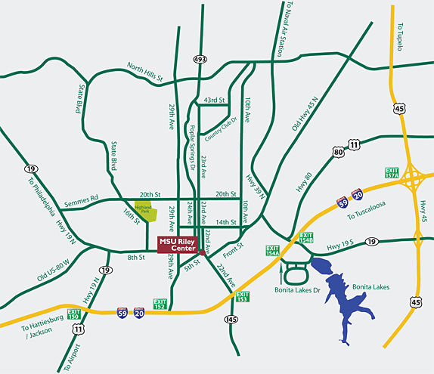
Driving directions from I-20:
Take 22nd Avenue exit 153 to downtown Meridian, travel 1 mile and arrive at the MSU Riley Center on the corner of 22nd Avenue and 5th Street.
Parking:
The MSU Riley Center is conveniently complemented by the Arts District Parking Garage located two blocks away at 712 24th Avenue.
Directions to the Arts District Parking Garage located at 712 24th Avenue:
- Turn left on 8th Street
- Turn left on 24th Avenue
- Parking deck entrance is on your immediate left

